**Bash script assignment -2**

***Task -1:***

***Create a bash script to check if a directory is available or not.***

*Create a file with extention of bash/.sh*

*Enter the Bash Script as the given syntax*

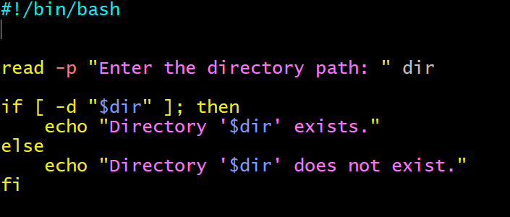

Giving permissions by using chmod 755.

Execute the data by using ./filename.sh.

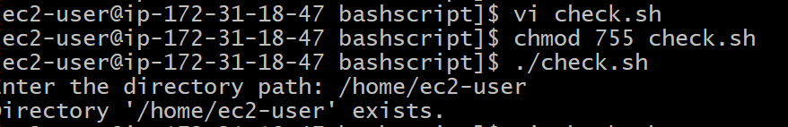

**Task -2:**

**Create a bash script to create multiple files.**

create a file with the extension of bash.sh

Enter the Bash script as below

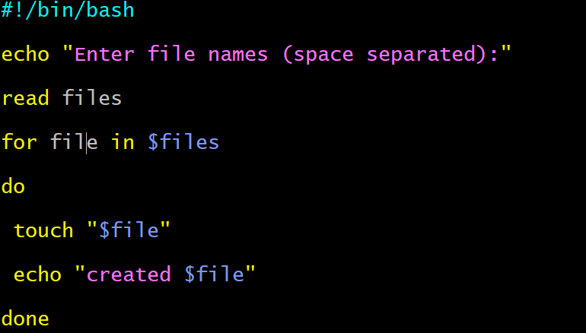

Giving permissions by using chmod 755

Execute the script by using ./filename.sh

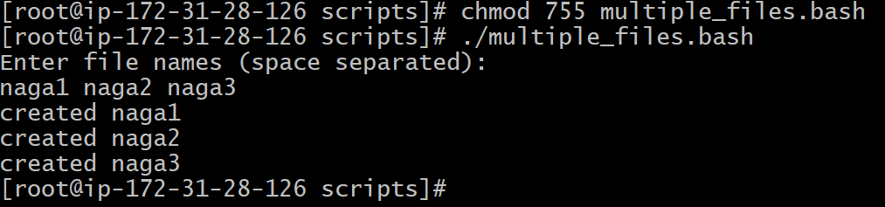

**Task-3**

**Create a bash script to take a backup of a directory.**

create a file with the extension of sh

Enter the bash script as below.

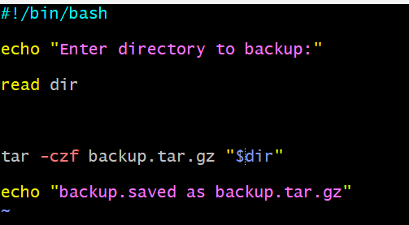

Giving permissions by using chmod 755.

Execute the script by using ./filename.sh

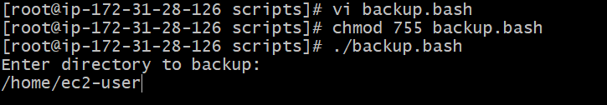

**Task-4**

**Create a bash script to install Nginx on an EC2 server.**

**Sudo yum install nginx -y**

**Sudo systemctl start nginx**

**Sudo systemctl enable started**

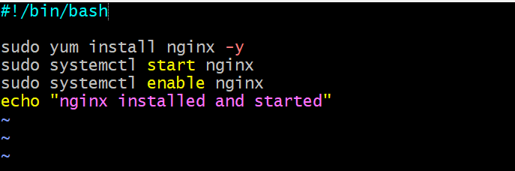

Giving the permissions by using chmod

Execute the script by using ./nginx.bash

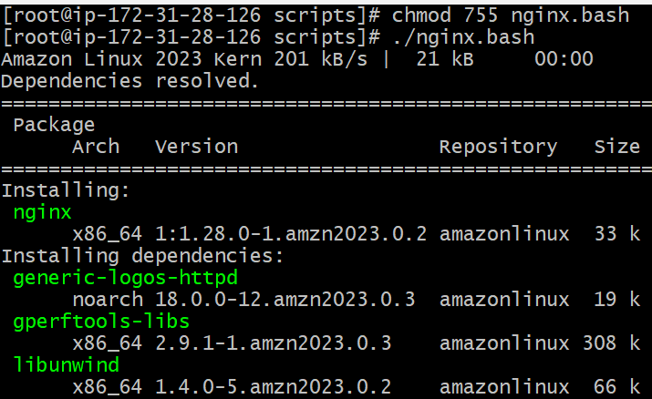

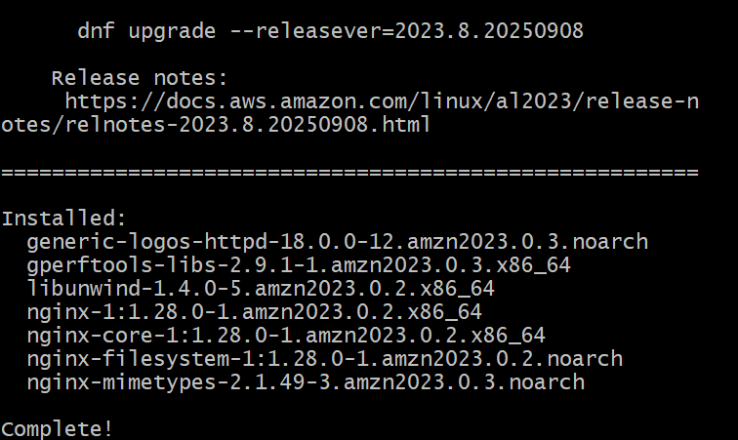

**Task-5**

**Create a bash script to install Apache Tomcat on an EC2 server.**

**sudo yum update**

**sudo yum install tomcat10**

**sudo yum start tomcat10**

**sudo yum enable tomcat10**

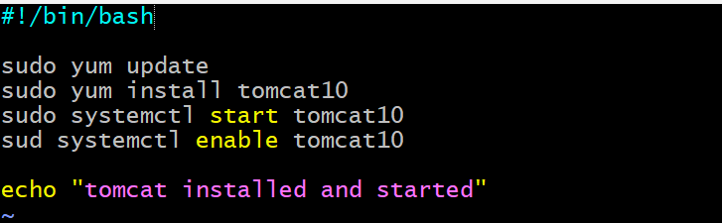

Giving permissions by using chmod 755.

Execute the script by using ./tomcat.bash.

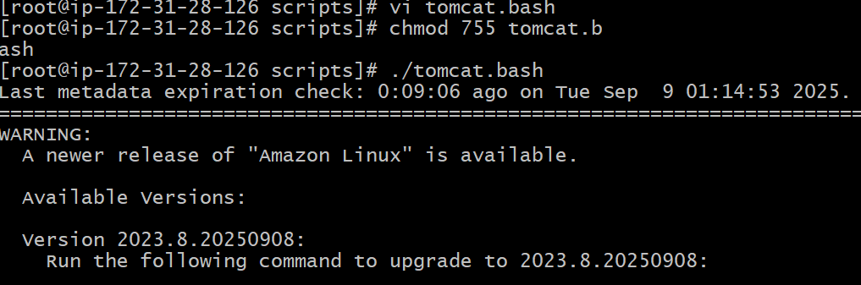

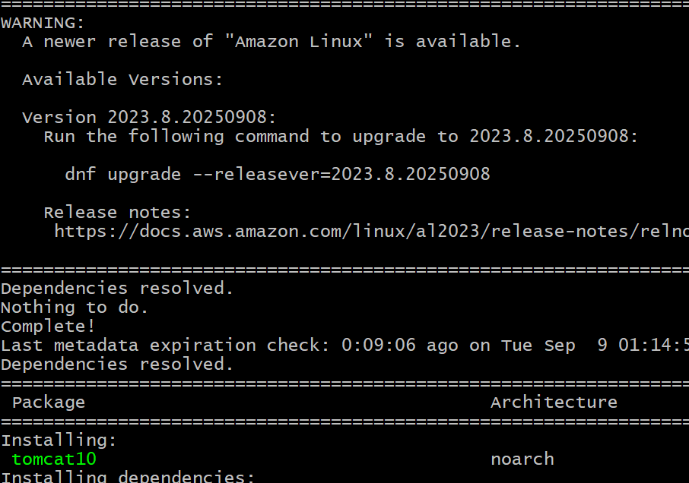

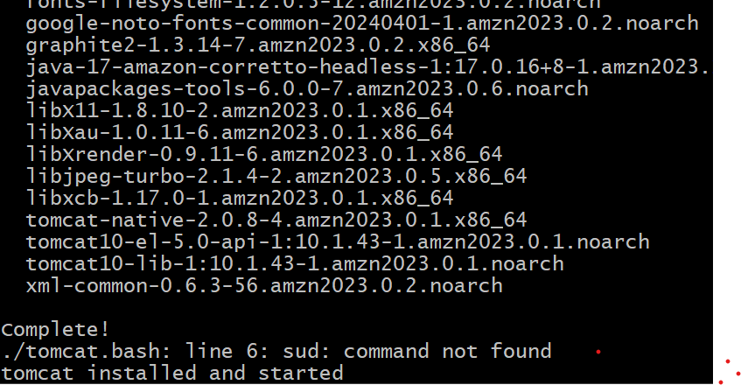

**Task -6**

**Create a bash script to check if the Nginx service is running, if not running then script should start the service**

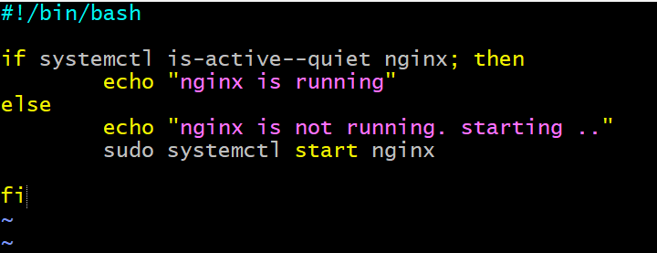

Create a file with the extension of sh

Giving permissions by using chmod755

Execute the script by using ./filename.sh

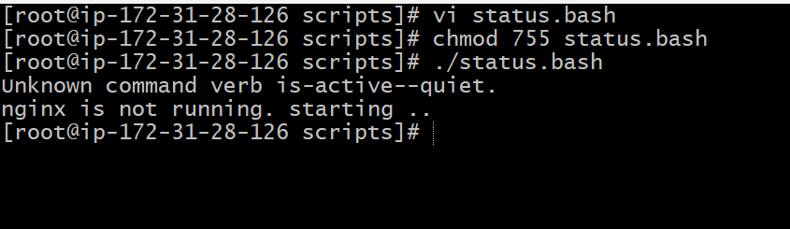

**Task-7**

**Create a bash script for a calculator**.

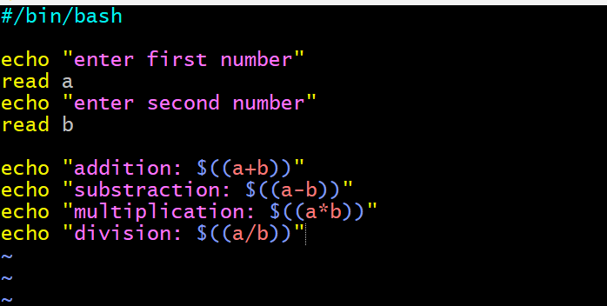

Create a file name with the extension of sh

Giving the permissions by using chmod 755

Execute the file by using ./filename.sh.

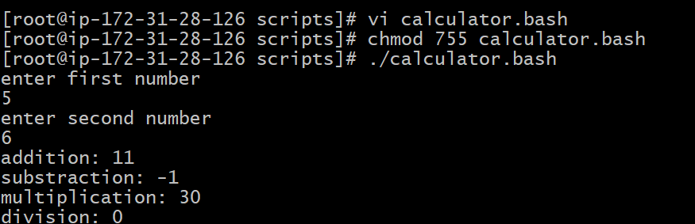

**Task -8**

**Create a bash script to check if a directory exists, if not then create a directory.**

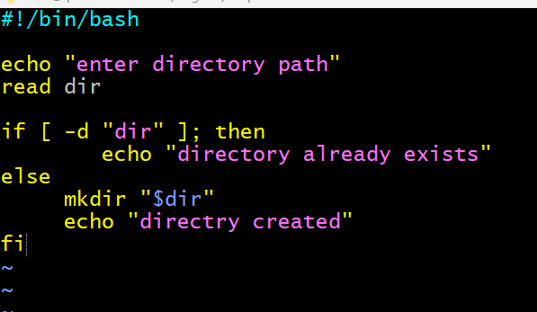

Create a file with the extension of sh

Giving the permissions by using chmod.

Execute the script by using ./filename.sh.

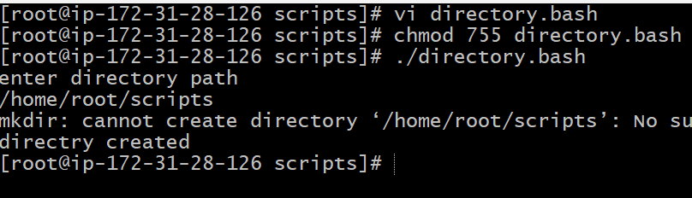

**Task-9**

**Create a bash script to delete the last 3 lines of a file.**

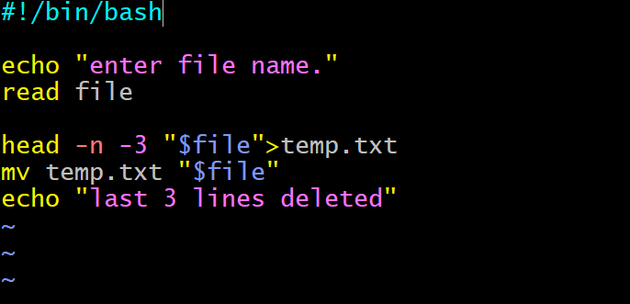

Create a file with the extension of sh

Giving the permissions by using chmod755

Execute the file by using ./filename.sh.

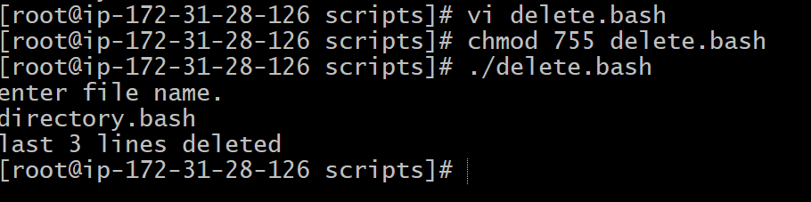

**Task-10**

**Bash script to monitor cpu and if it is more than 80% then send email notification**

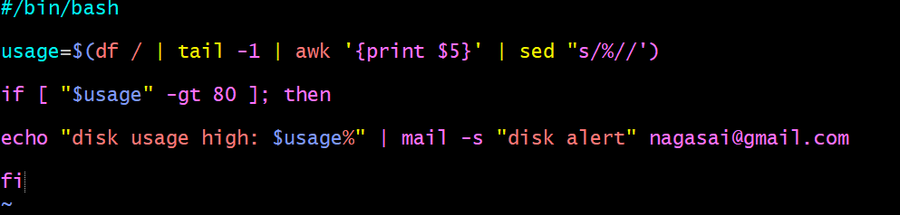

Create a file with the extension of sh

Giving permissions by using chmod755

Execute the file by using ./filename.sh.

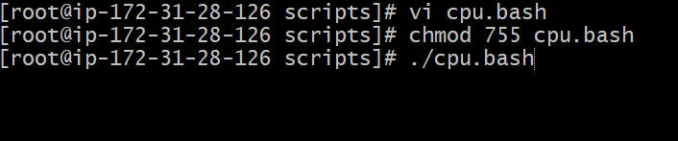

**Task-11**

**Bash script to monitor disk space and if it is more than 80% then send email notification.**

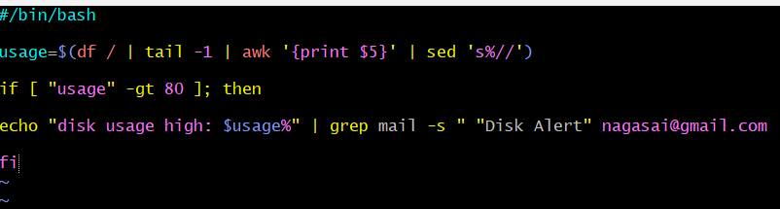

Create a file with the extension of sh

Giving the permissions by using chmod755

Execute the file by using ./filename.sh.



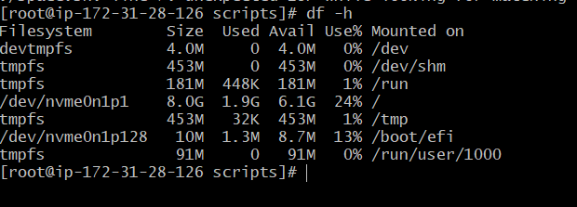

**Task-12**

**Bash script to monitor memory and if it is more than 80% then send email notification.**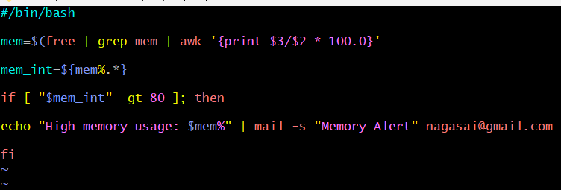

Create a file with the extension of sh

Giving the permissions by using chmod755

Execute the file by using ./filename.sh.



